Legal Analysis of Demerger in Corporate

WE HAVE DONE END TO END ANALYSIS OF DEMERGER PROCESS IN INDIA KEEPIN IN MIND OF INCOME TAX ACT.

NAME OF THE COMPANY | ABC HIREPURCHASE PVT LTD
REGISTERED ADDRESS | FIRST FLOOR, 60-D, DELHI, -110051
DATE OF INCORPORATION | 02/04/1993
PAID UP CAPITAL | 2,60,50,090/-
EMAIL ID | xyzcapital@gmail.com
REGISTRATION NUMBER OF COMPANY(ROC) | 006666
WHETHER LISTED OR NOT | UNLISTED
PAN NO. | AABCK2724M
AO CODE | ITO WARD-2(2)-Delhi
DIRECOTRS | 1.KAILASH SHARMA(DIN XXXXXXXX)  2.VEENA SHARMA(DIN XXXXXXXX)

Our Taxation Services and Regulatory Advisory Services Practice
We can help you manage business and regulatory risks, particularly in the area of:-
- Licensing and Authorization
- Investment product authorization
- Governance , oversight , systems and controls
- Keeping pace with regulatory changes
- Fraud and breaches remediation
- Legal entity structures
- Regulatory filling and reporting
We are a team of dedicated regulatory specialists within taxation services practice of Enterslice, who have hand –on experience in advising and assisting our clients in meeting compliance obligation and regulatory challenges.
Our team has a unique blend of regulatory expertise and comprises former Tax advisors, accountants, Lawyers, former regulators and industrial professionals. The team is also populated by consultants who have a mix of process, controls and technology credentials who focus on bringing “Change” to your organization. Moreover, we work closely with Enterslice ‘Global network of Professionals, which enables us to assist our clients anywhere in the world

CONTENT

Particulars Page No.

- Indian Economy 1
- Definitions 2
- Case 3
- Conditions of Demerger 4-5
- Provision applicable to companies 5-6
- Provision applicable to shareholders 6
- Recommendation 7

DISCLAIMER: - This sample report has been prepared on the request of the client only for a specific purpose. Further, any notification/ circulars after publishing such sample report shall not make liable to ENTERSLICE.
Any further publication or reproduction of such sample report is strictly prohibited and shall not make liable to ENTERSLICE.
Further, this report has been prepared by keeping in view Income tax compliances only.

1

INDIAN ECONOMY

In the era of globalization by various economic reforms and political changes has been taken place in India. India has emerged as the global leader to provide strengthen the global market.
In India, there are multiple companies which are diversifying by demerging their self among different subunits which have to provide to strengthen to the companies to focus each subunit in their core area with ultimate goal to nation growth

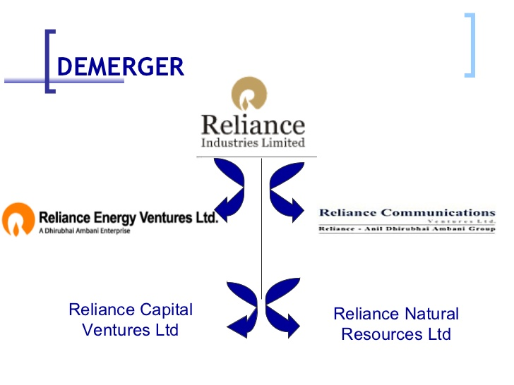

2

DEFINITIONS OF DEMERGER

Undertaking: includes any part of an undertaking or a unit or division of an undertaking or a business activity taken as a whole, but excludes individual assets or liabilities or combination of both not constituting a business activity.
Demerged Company means the company whose undertaking is transferred to a resulting company pursuant to a demerger.
Resulting Company: means one or more companies (including wholly owned subsidiary thereof) to which the undertaking of the demerged company is transferred in a demerger and the resulting company in consideration of such transfer of undertaking, issues shares to the shareholders of the demerged company and includes any authority or body or local authority or public sector company or a company established, constituted or formed as a result of demerger.

3

CASE

The Company ABC Hire Purchase Pvt. Ltd. wants to get itself demerged them wants to transfer their one of the assets. After demerger there will be two company, one is ABC Hire Purchase Private Limited (Demerged Company) and another will be XYZ Capital Private Limited (Resulting Company).

4

CONDITIONS OF DEMERGER
Demerger (Section 2(19AA)): As per Section 232 of the Companies Act 2013 the whole or any part of the undertaking, property or liabilities of any company (hereinafter referred to as the transferor company) is required to be transferred to another company (hereinafter referred to as the transferee company), or is proposed to be divided among and transferred to two or more companies,
- All the Assets/liability of the transferable undertaking becomes the assets/liability of the resulting company from the result of demerger.
- All the assets/liabilities are transferred at book value (Revaluation shall be ignored).
XYZ CAPITAL PRIVATE LIMITED (RESULTING COMPANY)
ABC HIRE PURCHASE PVT LTD
ASSETS & LIABILITIES
OF UNDERTAKING AT BOOK VALUE

- The resulting company shall issues shares to the shareholders of the demerged company on a pro-rata basis, except inter holdings.
- Shareholders holding minimum 75% of the value of shares become shareholders of the resulting company (inter holding shall be ignored either it is way of subsidiary or nominee)

XYZ CAPITAL PRIVATE LIMITED
ATLEAST 75% SHAREHOLDERS (In Value) OF ABC HIRE PURCHASE PRIVATE LIMITED
Become Shareholder of
.

5

- The undertaking shall be transferred on a going concern basis.
- The demerger is in accordance with the conditions notified under Section 72A (5) of IT Act, 1961.

PROVISIONS FOR THE COMPANY
Capital Gains {Sections 47(vi) and 47(vid)}
- In pursuant to a scheme of Demerger Gains arising on transfer of a capital asset to the resulting company being an Indian company is EXEMPT.

Carry forward of accumulated loss and/or unabsorbed depreciation (Section 72A).
- The Resulting Company can carry forward the accumulated Loss & unabsorbed depreciation transferred in pursuant to a scheme of demerger and can be set off against their profit.
- If it is directly relatable to such undertaking then it should be such relatable amount.
- If it is not directly relatable to the entity then it should be apportioned in the ratio of assets transferred to and assets retained by the resulting company and demerged company respectively.
Admissibility of Expenditure relation to Demerger (Section 35DD)
- An Indian company shall be allowed a deduction of 1/5th of the total expenditure incurred in relation to demerger for the period of 5 years from the year in which event took place.
Depreciation in the year of in which demerger took place {Fifth proviso to Section 32(1)}
- Depreciation shall be apportioned to the demerged company and resulting company on the basis of a number of days of assets used by both companies.

6.

Written Down Value (‘WDV’) {Sections 32 and 43(6) (c)}.
- In case of a Resulting company, the WDV shall be the WDV of the transferred assets immediately before demerger.
- In case of Demerged company, WDV shall be:-
WDV of the block of Assets – WDV of the transferred assets

PROVISIONS FOR THE SHAREHOLDERS
- The shareholder of the company who acquired a share in resulting company pursuant to a scheme of demerger will not be taxed either as capital gains or deemed dividend {Sections 47 (vid) and 2(22) (v)}.
- Period of the holding of shares of the resulting company shall include the period for which the shares in the demerged company were held by the shareholder. {Sections 2(42A) (c) and 2(42A) (g)}.
- Cost of acquisition of shares of:
  - The resulting company in case of demerger will be the (Section 49(2C)):
Original cost of shares of demerged company X net book value of assets transferred to resulting company/net worth of the demerged company before demerger
Net worth = Paid-up Share Capital + General Reserve as per books of demerged company immediately before demerger
  - The demerged company will be the original cost of shares of the demerged company as reduced by the cost of shares of the resulting company as computed above (Section 49 (2D)).

7
RECOMMENDATION
After observation and through various compliances of income tax it is recommended to the organization demerger of the organization is not possible due to following reasons:-
  - The individual asset does not constitute undertaking
  - The company does not have any other segment of business, branch or subsidiary which they get demerged
However, it will be the sole discretion of the organization either to adopt such recommendation or not.

