LEGAL NOTICE
Ref. No. ______
Dated ________

To,
M/s/………………………………
Place……………………………
Dear Sir,
Pursuant to the instructions from and on behalf of my client ………………….., I do hereby serve you with the following Legal Notice: -
- That my client is a company under the name and style of M/s ……………
- That my client is engaged in the business of providing financial and legal services.
- My client was taking internet services from Spectra from past __________.
- Here are the details of the internet package:
Lease Line of 10 MBPS charging amount for the services ………..+ taxes. Yearly.
During the term, September – October my client suffered from the huge loss of ______ Rs. due to the no internet connection from ……………… to …………….. from the service provider. For this period my client has already paid the amount as per monthly billing.
- An employee of my client requested you for efficient services several times through telephone and emails but you have always been delaying in response.
- My client is also claiming that internet services were not up to the terms mentioned that you have claimed to provide internet speed of 10 MBPS but my client was receiving the speed between 2 to 6.43 MBPS only.
Below is the screenshot of speed captured on 30/10/2017 (Date) at12:22 PM.
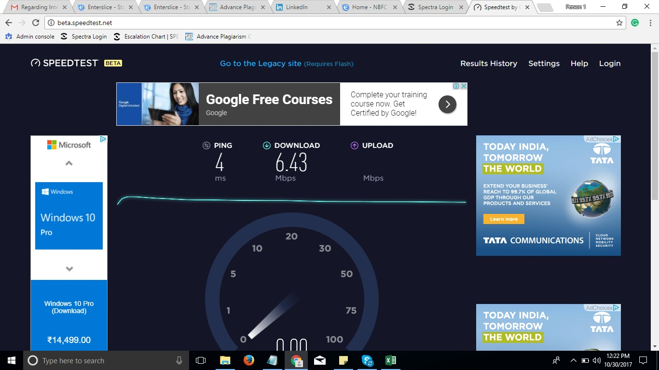
- I therefore, through this Notice finally call upon you to pay the damages to my client either in cash or by demand draft or Cheque whichever mode suits you better, within clear 15 days from the date of receipt of this notice, failing which my client has given me clear instructions to file civil, criminal., suit for recovery and other Misc. proceedings against you in the competent court of law and in that event you shall be fully responsible for the same.
A copy of this Notice has been preserved in my office for record and future course of action.
( ___________ )
Advocate

